ROCKING THE KREMLIN

Russia’s biggest rock star paved the way for Putinism, but has now become an obstacle to the regime

Arkady Ostrovsky joins the band
AUGUST/SEPTEMBER 2017 (The Economist)
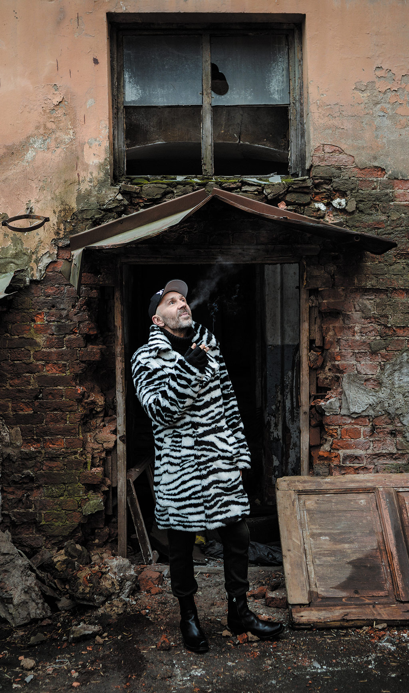
Eto ne ya (“It’s not me”) says Sergei Shnurov’s T-shirt. As Russia’s most popular and controversial rock star waits to go on stage for the 20th anniversary concert of his band, Leningrad, he lights one Marlboro cigarette from another while holding his nose so the smoke goes deeper into his lungs. “‘It’s not me’,” he explains, “is what children say when they are caught doing bad things.”
Shnurov has been doing bad things for two decades – drinking heavily, smoking intensely, swearing profusely and causing scandals with his obscenities and pranks. His nickname is Shnur – cord or cable. This particular Shnur is a fuse cord that detonates language and popular culture.
As he bursts on to the stage of St Petersburg’s largest stadium, images of explosions flash up on the screen behind. The “N” in LeNingrad, projected onto the backdrop, looks like lightning. Shnurov’s female vocalists undulate in sequinned catsuits the colour of the Russian tricolour. Whether the reference is patriotic or ironic is unclear.
In his hoarse, smoky voice, Shnur launches straight into one of his hits, “Ebubab”, a non-existent word which consists of ebu (“I fuck”) and bab (“babes”) – something like “fuckababe”.
I’d like to say “hello!” to everyone.
I am – an animal of a rare breed.
Ebu, ebu bab
Ebu, ebu bab
Ebu, ebu bab
Ebu, ebu bab
Ebu, ebu bab
I am always hiding in an ambush
I can do [it] from the front and I can
do it from behind.
Singing it on the eve of International Women’s Day – a staple Soviet-era holiday on which men are expected to give women flowers – makes the opening number all the more outrageous.

The audience loves the act – even though it appears to have little in common with the character on stage. It is made up of well-heeled, well-behaved thirty- and forty-somethings; he is foul-mouthed and burdened neither by intellect or education, only by a heavy gold chain around his neck. He looks like a guy from the outskirts of a city who made his first money by running a street kiosk or selling counterfeit Levi’s in flea markets and sticks anti-American slogans on the back of his second-hand American car. He operates in cash and lives in the present.
But, as the T-shirt says, “It’s not me”. Sergei Shnurov is a former student of philosophy and religion, an art restorer, a conceptual artist and a successful showman who tops the RussianForbes’s show-business list. In conversation, he is obliging, professional and reflective.
Shnur is a construct of Shnurov’s imagination, built from popular culture, Russian literature, Soviet myths and their post-Soviet deconstruction. Like any artwork there are multiple references. One could, for example, trace his roots to the tradition of skomorokhs – medieval jesters who performed at fairs, combining music, dance and drama, and whom the church called “devil’s servants”. The influence of heavy-drinking intellectuals of the 1970s, semi-official bards who sang their poetry to the accompaniment of an acoustic guitar can be seen in his work, as can late Soviet prison-slang chansons.

Whatever the elements from which his alter-ego has been created, Shnurov possesses an unfailing sense of popular appetites and unparalleled marketing skills. He is famous throughout society – admired by taxi drivers, skate-boarders and nerds, CEOs and clerks, people who protest against the Kremlin and those in the Kremlin who send the police (also fans) to disperse them. His lines have turned into national memes. Shnurov has captured the paradoxes and idiosyncrasies of post-Soviet Russia, described the mutations of Homo sovieticus and reflected the zeitgeist of Putin’s era.
He sings at corporate events, in sports arenas and at parties thrown by oligarchs. He is comfortable in all these venues, but his favourite form is the narrative music video between seven and ten minutes long. These films, which he makes with some of the country’s best writers and directors, are watched on YouTube by tens of millions of fans who then pay to go to his concerts to hear a familiar soundtrack.
Leningrad, his band, is a motley crew, including a fat drummer in a red T-shirt known as Puzo (Belly), a girl with Playboy bunny ears and a black monk in sunglasses. They look less like a rock band than a bunch of clowns. Shnurov calls them a grupirovka, a word usually reserved for a criminal gang. “A band is the Beatles or the Rolling Stones. We have different tastes and no common vision, ideals or views. We are like a mafia or a band of pirates who are together only because one is the best gunman, while the other is the best swordsman.”
Like Putin, Shnurov is the product of his native city. St Petersburg – Leningrad during the Soviet period, and now St Petersburg again – has always been a troubled and troublesome place. Conceived by Peter the Great as a model European city, it was built on a swamp at the cost of thousands of lives. A city of baroque grandeur, it is known also for its dark courtyards and crumbling houses in which the characters in Dostoevsky’s novels dwell. It regards itself as intellectual, and Moscow as materialistic. In the days of the Soviet Union, it became a symbol of resistance.
Shnurov was born in 1973 into a family of the so-called technical intelligentsia nurtured by the Soviet system. His parents were engineers. When he was growing up, the city’s palaces and churches, most of them built by western European architects, were a visible testament to the failure of the Soviet experiment, and the contrast between the tourist St Petersburg and the everyday Leningrad was particularly stark. During the white nights when the sun hardly sets in the sub-Arctic latitude, he and Belly would submerge themselves in one of the city’s canals, waiting for a tourist boat to go past. When the guide was pointing at some imperial sight, they would emerge from the water, exposing their bare backsides to the amused tourists.
As a port city and a prime destination for foreign tourists in the late Soviet period, Leningrad was a centre of fartsa – black marketeers who traded in foreign labels, currency and popular music. Sidelined politically and economically by Moscow, it was also an incubator for informal youth culture – art and rock – which not only rejected but ignored official Soviet culture and ideology. In 1987 Viktor Tsoi, a razor-sharp 25-year-old rock singer from Leningrad, sang a song that became a Marseillaise for the era:
Changes!
Our hearts demand changes!
Changes!
Our eyes demand changes!
In our laughter and tears and in our pulsating veins,
Changes!
Change was already in the air. Mikhail Gorbachev, the president, was opening up the Soviet Union. When in August 1991, the KGB and the hard-liners in the Communist Party mounted a coup against him, Shnurov was “distributing leaflets and assembling a bomb, in case the tanks went along my street.” The coup’s failure marked the end of the Soviet empire. “I remember this feeling of euphoria, a feeling that something big, interesting and free is about to start,” Shnurov recalls.
He began an engineering degree, but it seemed absurd. “When everything is falling apart, what is the point of studying construction?” He dropped out and trained as an art restorer. “I figured being a restorer in a museum city could always bring in a living.” He made his first money by making copies of Dutch Old Masters, which he sold to a Polish intermediary who flogged them in Germany.
Like pirates, they are driven not by ideology but by profit and a desire for domination. “We simply grab more and more territory. We don’t care who we rob as long as we dominate in these waters.”
Shnurov’s gang conquered the country in 2000 – around the same time as another grupirovka from St Petersburg, led by Putin, then a little-known KGB officer, took over the Kremlin. The two men have nurtured each other. The government’s corruption encourages nihilism while the rock star’s songs legitimise indifference. Shnurov is Putin’s guardian devil, but the cynicism he fosters also makes the regime vulnerable and ultimately fragile.

When Russian nationalists and communists led an armed revolt against Boris Yeltsin’s government in 1993 and civil war loomed, he decided to study philosophy at a theological academy. “I was looking for a foundation, some knowledge that would withstand any political cataclysm,” he says. In the intervals between reading the Old Testament and Nietzsche he worked as a blacksmith, making fences and decorations for fresh graves: rival criminal gangs were carving up spheres of influence, providing a steady flow of orders. By the late 1990s, the gang war was over and Shnurov started writing songs celebrating the lives of bandits.
He called his first band “Van Gogh’s Ear”. It played in a rock café called Art Clinic to the accompaniment of a phonogram. “It was our Duchamp’s urinal. We rebelled against all those ‘rock values’, against ‘confession’ and ‘protest’, because there is nothing more commercial than protest in Russia…And if you are making a confession, why the fuck do you charge 20 roubles a ticket?” The band, part of St Petersburg’s fringe, got little attention elsewhere.
In Moscow, Russia’s elite was remodeling the country in the image of the West. Kommersant, the country’s first private newspaper, copied the New York Times, portraying a new world with solid banks and stock exchanges. It defined its reader as a new type of Russian man: “clever, calm, positive and rich”. NTV, the country’s first private television channel, was producing programmes suitable to a normal Western country.
But the reality was far from normal. Russia was fighting its first war in Chechnya and its economy was rapidly contracting. While the Russian elite dressed like its Western equivalent, it lacked any sense of responsibility for its country. “Everything that was happening in Russia in the 1990s was a parody of capitalism, a twisted, distorted image of Western life. The privatisation, the restaurants, the bourgeoisie – it was all a parody. They [Russia’s first capitalists and oligarchs] pretended to have haute cuisine – but it did not taste like one and copying the West did not bring them closer to it,” he says.
Kommersant rejected the Soviet past as redundant and irrelevant (the masthead stated that “the newspaper was established in 1909 and did not come out between 1917 and 1990 for reasons outside editorial control”). Shnurov does not. “We all are, whether we like it or not, Soviet products. Some of our organs have grown disproportionately. We have learned to live in a paradox and feel no discomfort from it. A confluence of a red star and a Russian tricolour does not cause us a cognitive dissonance – hence the ease of ideological manipulation.”
He called his band Leningrad as a deliberate affront to the reversion to pre-revolutionary names. It was not an act of nationalism. An admirer of Led Zeppelin, he rejected not Western culture, but Russia’s attempt to imitate it. He didn’t want to be a Russian copy of a Western band: he wanted to be an authentic Russian voice. “But if you want to have your own Led Zeppelin, you need to find your own base, your own Chuck Berry.”
In the search for cultural roots, Shnurov turned to the language's lowest denominator – swear words. “When everything had been destroyed, when all there is left is parody and simulacra, when everyone is trying to be like someone else, I started looking for a foundation of our fucking Russianness, for something that we can not exist without and soon realised that the only word that can be neither devalued nor enclosed in inverted commas is a three-letter one” (four in English).
Vladimir Sorokin, one of Russia’s most controversial post-modernist authors, provided the vocabulary for his art. Sorokin reduced human nature to its basest level and desecrated the language along with the notion of Russian literature as something that has a social and moral purpose. Shnurov was particularly taken by Sorokin’s novel “Norma” (The Norm), in which the state requires people to eat a daily dose of human excrement.
But whereas Sorokin’s prose had, unsurprisingly, few fans (“I can’t see how anyone could enjoy it,” he once told an interviewer), Shnurov made decomposing the language sexy. Whereas Sorokin reviled human nature, Shnurov celebrated its baseness. His songs were simultaneously toxic and optimistic.
His first album, “The Bullet”, hit the spot. His second, “Profanity Without Electricity”, took the country by storm. Like alcohol (which he consumed in great quantities), his crazed, obscene, triumphant songs had an anaesthetic effect, removing inhibitions and alleviating the pain of post-imperial trauma, the disastrous war in Chechnya and the decade’s disappointed hopes. Russia’s romance with the West and with liberal ideas was over, thanks to the financial crisis of 1998 and the bombing of Yugoslavia by NATO forces. “I felt I had grabbed the time by the balls,” Shnurov says.

The time did not resist. As Maksim Semelyak, a music critic and Shnurov’s biographer, wrote, the era was “submissive, rather than exciting”. It submitted to Shnurov’s songs and to Putin’s narrative of resurgence. The economy obliged them both. Spurred by the devaluation of the rouble and the rising oil price, it was soaring. Coffee shops, new Western-style cinemas and fitness clubs sprang up. Russia was having fun.
Shnurov caught the mood of frustration mixed with exuberance. He was all the rage among intellectuals, journalists and the children of the old intelligentsia who gathered in private Moscow clubs – a modern, fashionable equivalent of Soviet kitchens – and drank themselves senseless to the accompaniment of Shnurov’s obscenely euphoric songs. A few were troubled. “If only he knew what sort of demons he is releasing,” said Boris Grebenshchikov, a veteran St Petersburg rock singer and poet.
In 2001 Vedomosti, a business daily set up by the Financial Times and the Wall Street Journal, picked Shnurov as their man of the year in the arts and culture category. “His performances”, it wrote, “bring together office clerks, snow-boarders, fashionable book publishers, heavies from the outskirts of cities in a joint ecstasy. How did a 27-year-old playboy manage it? With what idea? It is simple. He won people’s minds not with an idea, but with its absence.”
But outside Moscow’s bars, ideas were festering. A powerful strain of Russian nationalism was percolating through popular culture. The country’s first indigenous blockbuster film, “Brat” (Brother), articulated a simple and enticing idea: the Russians are strong because they are morally right and they are morally right because they are Russians. The Kremlin recognised the powerful appeal of both Shnurov’s nihilism and the nationalism of “Brat” and, improbably, tried to co-opt them into a single narrative.
In 2004, after a popular pro-Western uprising in Ukraine which was interpreted in Moscow as a Western encroachment on the Russian sphere of influence, Vladislav Surkov, the Kremlin’s chief ideologue and a post-modernist writer, set up a pseudo-nationalist youth movement and tried to get Shnurov to endorse it. He borrowed the movement’s name – Nashi (Ours) – from Dostoevsky’s “The Devils”, in which a pseudo-socialist scoundrel explains: “The essence of our creed is the negation of honour…By the open advocacy of the right to be dishonourable a Russian can be won over more easily than by anything else.”
As a token of his respect and in expectation of future collaboration, Surkov’s people presented Shnurov with a Vertu phone worth some $20,000, with a concierge service on speed dial. Shnurov took the phone but declined the request, remembering that, a couple of years earlier, Surkov’s people had flushed Sorokin’s novels down the toilet in front of the Bolshoi theatre. The phone ended up in the hands of one of his musicians, who, during a tour in Germany, called the concierge: “We are in Cologne,” he said. “How do we get in touch with a local drug dealer?”
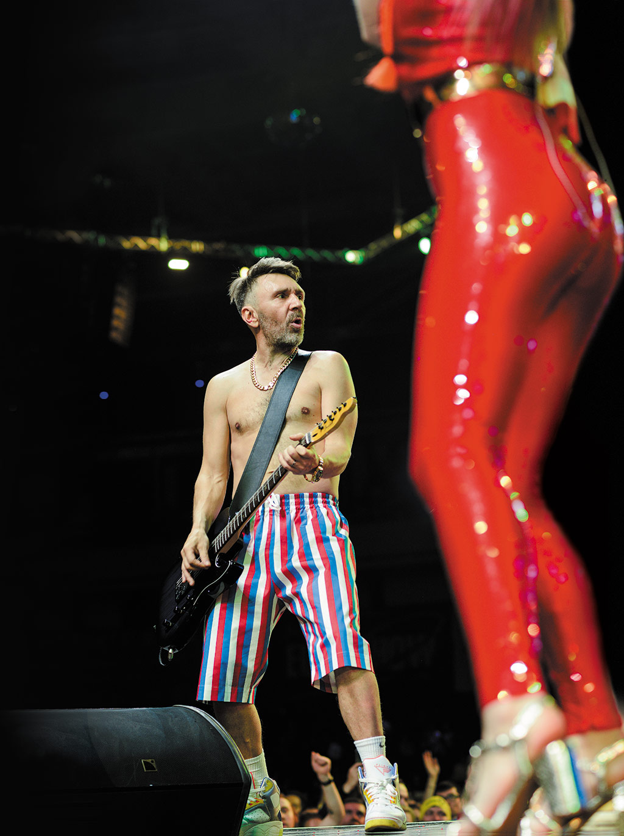
By 2007, both the oil-fuelled economy and Shnurov’s popularity showed signs of overheating. That year the singer made a cameo appearance in a re-make of an iconic film of the perestroika era that marked the 30th anniversary of Viktor Tsoi’s song “We Demand Changes”. Standing on the same stage, Shnurov sang:
The pulse in the veins is getting weak
We no longer long for changes.
There is no fire, just smog
And nobody will die young.
We are longing – but not for changes
Shnurov drew a curtain on Leningrad almost at the same time as Putin stepped down as Russia’s president and put Dmitry Medvedev as a place-holder in the Kremlin. Neither was gone for long.

In 2010, Shnurov returned to the stage under the slogan “snova zhivy dlia nazhivy” (“we are back for a buck”). Putin too was planning a comeback as president. But his admission that it had been long-planned, and that he had never loosened his grip on power, sparked mass protests in Moscow and St Petersburg.
Shnurov mocked this sudden burst of civic activism:
Buy some tickets, brothers
I am democracy’s last rock star!
Sure, I will not lose out
I will get my percent
The ring of the falling cents is sweet
Drip, drip, drip, drip.
The lyrics chimed with a comment of Putin’s, accusing protesters of taking money from the American government and likening their white ribbons to used condoms. The protesters were the educated middle class who had once made up the core of Putin’s supporters and Shnurov’s audience. These people now demanded respect and dignity, so the cynicism jarred. Shnurov found himself out of tune with the times.
The Kremlin responded to the protests not just with repression, but also by promulgating a narrative about Russia’s destiny. It sought to trump the idea of a modern nation state with nostalgic imperial nationalism. It whipped up anti-Americanism under the guise of patriotism and traditional values. It rallied people around the flag and doped its athletes in the Winter Olympics so they would win the most gold medals. Then it gave the country the most powerful drug of all: war. Ukraine was invaded and Crimea annexed.

Shnurov, an individualist and a pacifist, was as troubled by this mass euphoria and patriotic fervour as he was by the protest. Outside the circus, things were getting serious. Thousands were dying in the war in Ukraine. Kremlin-paid thugs marched through the streets denouncing “the fifth column” and holding up portraits of national traitors in scenes reminiscent of 1930s Germany. Boris Nemtsov, Russia’s best-known liberal politician, was assassinated near the Kremlin.
Shnurov sensed danger in the new mood. The Duma (parliament) passed a law banning swearing on stage and in the cinema. His music might have been declared “degenerate” as easily as that of Pussy Riot, a punk group whose members had received two-year jail sentences for singing an anti-Putin song on the altar of the Cathedral of Christ the Saviour in Moscow.
Shnurov hedged his bets somewhat, accepting an invitation from a Kremlin-friendly banker to sing at a private party in Crimea attended by the prime minister in 2015. But he also mocked patriotic euphoria. In one music video, a super-rich Russian socialite driving a Bentley through the Tuscan countryside sang: “I like the flag: it is so stripy and sweet/I am clearly, very clearly, a patriot.” Another video, with a plague-on-all-your-houses message, dreamed “a wonderful dream” of Red Square, Putin, his opponent Alexei Navalny, a television tower, Pussy Riot and the Cathedral of Christ the Saviour – all ablaze and washed with acid rain. It is a vision of imperial Russia’s Ground Zero.
Shnurov’s nihilism, which once helped the Kremlin to monopolise power, has become an obstacle to selling the nationalist narrative. The polls may rate Putin’s popularity at over 80% but, Shnurov says, “nobody gives a fuck…If you ask people whether they support a building across the street, 90% will say yes. But when a bulldozer comes to tear it down, nobody will come out for it.”
Shnurov’s own vision of Russia differs from the Kremlin ideologues’. It is best expressed in “The Exhibit”, a music video that has been watched over 100m times on YouTube, making it the most popular Russian video ever. It starts with a Skype conversation between an angelic-looking girl with flowers in her hair talking to a swanky-looking businessman. “I used to live there like a bird in a cage,” she says. “But I finally told him: ‘Dad, I don’t need your money, I don’t need all these diamonds, Mercedes cars. I have to achieve everything by myself. And now I am renting this place and I paint once in a while.’”
Impressed by her looks and her story, the businessman asks her to an exhibition. The Skype call over, the camera reveals that she shares a run-down St Petersburg apartment with her mother. She is a girl on the make.
Inspired by a model on a page from a magazine pinned to her wall, she borrows a pair of high-heeled shoes from a friend and paints their soles with red nail-varnish to make them look like Louboutins; she waxes her body hair and extends her eyelashes; but she can’t get her jeans on. So she wraps her thighs in cellophane and gets on an exercise bike, drinks a solution of potassium permanganate and makes herself vomit.
Her mother, hair in rollers, walks in. “Stop wasting your fucking time,” she tells her daughter. “Better go and get some bread.”
“Get what?” asks the girl.
“Bread. There is no bread at home.”
“Yeah, can’t you see? Already on my way! From now on I don’t see this bread shit ever again!”
“Don’t you dare to talk like that about bread! Our grandma survived the Nazi blockade!”
“Grandma survived it, but I am screwed. Why the fuck did you give birth to me with such a fat ass?”
The mother helps the girl get her jeans on. But as the doorbell rings and she goes to let her date in, the nail-varnish on the soles of the shoes sticks to the floor and she falls on her face. Her eyelashes come off, her nose bleeds and her jeans split. The video ends with a stream of white light coming through the door that could be blessing or blankness.
The story is a parody of Cinderella, in which a fairy pinned to the wall cheats the girl. But it is also a metaphor for Russia’s failed date with the West. She pretended to be something she wasn’t, and fell on her face as a result. But if the Louboutins are fake, so is the harping on the Soviet victory in the second world war – the staple of the Kremlin’s ideology.
The Russia Shnurov portrays may seem ridiculous, but he clearly has an affection for her. She’s vulgar, she has a large ass, but at least she’s real.
She is also vulnerable. “Any empire”, said Shnurov at a recent opening of an exhibition of his art, “gravitates towards disintegration. Russia is cracking at the seams but for now still stands. Sooner or later, however, it will fall apart.” The cracks are showing. A few weeks after Leningrad’s 20th anniversary concert, tens of thousands of youngsters born around the time that Putin became Russia’s president and Shnurov its most popular rock star took to the streets protesting against corruption and demanding change.
Shortly after the protests erupted, Alisa Voks, who sang “The Exhibit” and subsequently split with Leningrad, performed a video song in which, dressed as a sexy schoolmistress, she tells kids to stay at home and do their homework. It widely reported that the Kremlin commissioned the video. Shnurov scolded Voks on Instagram. Saying “fuck”, he wrote, “was also a form of protest against a cunt and a scoundrel.”
But Shnurov has no more intention of helping the protesters than he has of bolstering the regime they want to bring down. “I won’t even go there. It’s not my genre. I’ve resisted it all my life. I tried to destroy this fucking romanticism as an outdated genre. But this bitch keeps on coming back.”

Arkady Ostrovsky is The Economist’s Russia and Eastern Europe editor. His book, “The Invention of Russia: The Rise of Putin and the Age of Fake News” (Penguin), is now available in paperback

https://www.1843magazine.com/features/rocking-the-kremlin

Shnur’s Instagram: https://www.instagram.com/shnurovs/

